- Create an application which has 3 buttons one is add to bag, move to wishlist, add one + one sale items
- Whenever you will click on add to bag items should be updated and then the number of items should be notified
- add one + one sale items should have - and stop at 0 stating bag is empty
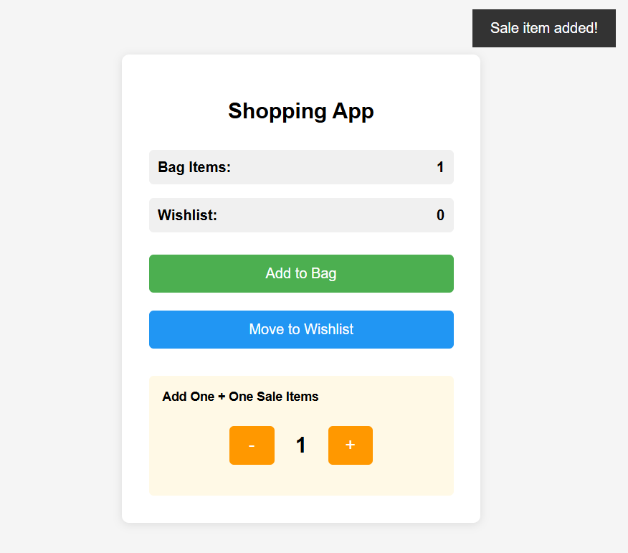
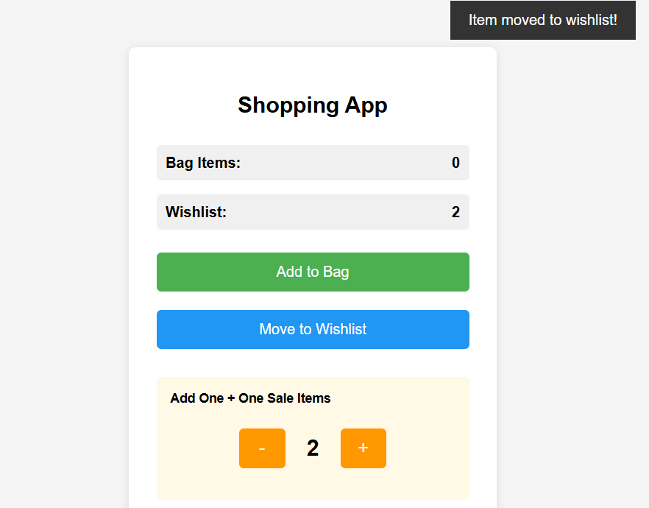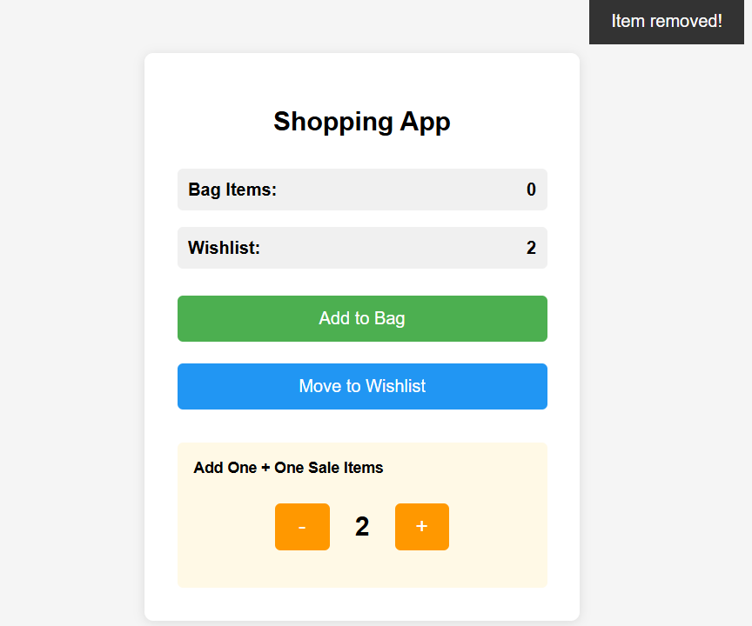

- Give discount based on age, gender for metro ticket
- Females get 50% off
- Kids under 5 years of age are free
- Kids up to 8 years have half ticket
- People Over 65 years of age only pay 30% of the ticket
- In case of multiple discounts max discount will apply.
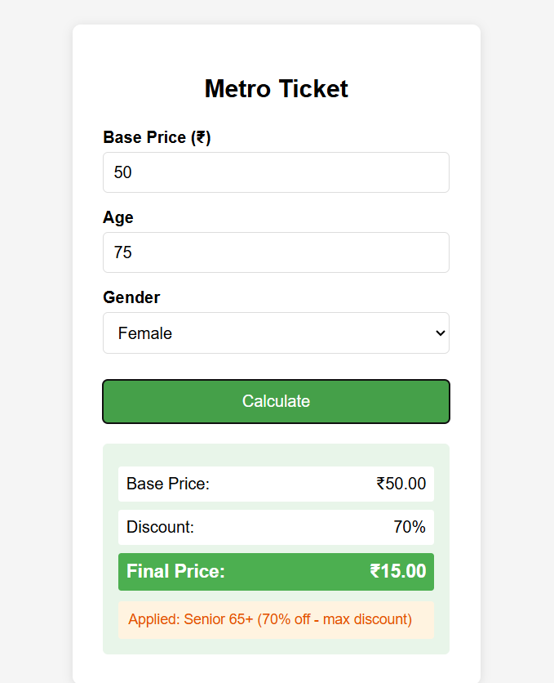
- Simple Calculator
